**Participate in a study**

**about your memory, thinking & health**

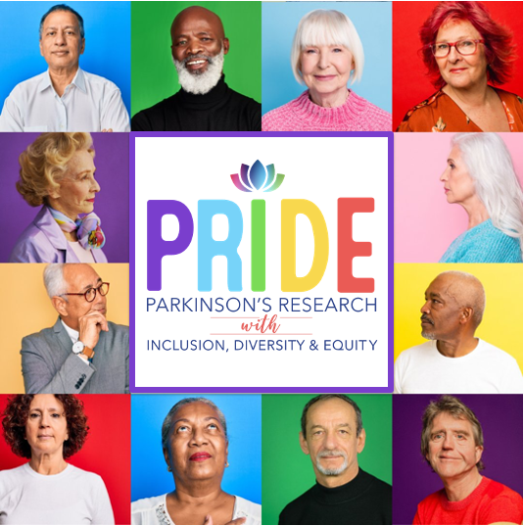



• Open to all adults aged 50 and older.

• Study involves participating in one-time 45-minute survey.

• Participation is voluntary and all information will be kept private.

• Complete the survey by calling us at: **702-895-5586**

• Receive a $25 gift card

Questions?

Contact the principal investigator, Jason Flatt, PhD, MPH

702-895-5586

This study is supported by the Alzheimer’s Association